HTML and CSS3 Material

Introduction to HTML

HTML Stands for Hyper Text Markup Language

HTML used to develop static web pages

Current version of HTML is HTML5.X

HTML Released by "Tim Berners Lee" in 1991

we will execute HTML with the help of "Browsers" Ex.

Google Chrome Mozilla

Opera IE

Safari

Netscape Navigator

IDE is used to develop the software applications Ex.

Notepad Edit Plus Notepad++

Visual Studio Code Eclipse

Visual Studio Code is Recommended IDE to develop web applications

Visual Studio Code provided by "Microsoft" and "open-source IDE"

CSS Stands for Cascading Style Sheet

CSS used to apply styles to web pages Ex.

color

background-color margin

padding border

border-radius

Current version of CSS is CSS3.X

Extension of CSS files is ".CSS"

JavaScript is the Scripting Language

JavaScript used to develop Dynamic Web Pages

JavaScript also used to implement the Forms Validations

Current version of JavaScript is ES13

ES Stands for ECMA Script

Extension for JavaScript files is ".js"

HTML is TAG Based Markup Language Ex.

<table></table>

<h1></h1>

<a></a>

<br>

<img>

<p></p>

<title></title>

<head></head>

TAGS Divided into two types

container/paired tags

non container tags/non paired tags

container/paired tags contains both opening and closing tag

non container tags/non paired tags contain only opening tag

closing tag should contain "/"

combination of opening tag, content and closing tag called as HTML Element

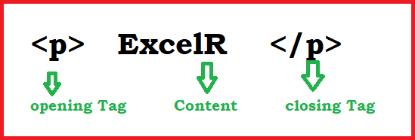

Attributes enhances html element functionality

Attributes are key and value pairs

key and value separated by using "="

Features of HTML5.X

WebSocket

WebSocket used to implement the chat applications WebSocket available in HTML5.X

Web Worker

Web Worker used to run JavaScript in Background Web Worker also available in HTML5.X

Storages API

HTML5.X Supports two types of Storages

Local Storage

Session Storage

whenever we close the browser/opens the new tab we won’t lost the data from Local Storage

whenever we close the browser/opens the new tab we will lose the data from Session Storage

Geolocation API

it is used to find the current location of user/device Geolocation API also available in HTML5.X

Drag & Drop API

This API helps to Drag and Drop HTML Elements This API also available in HTML5.X

Semantic Elements

HTML5.X Released New Elements/Semantic Elements Semantic Elements increases application readability

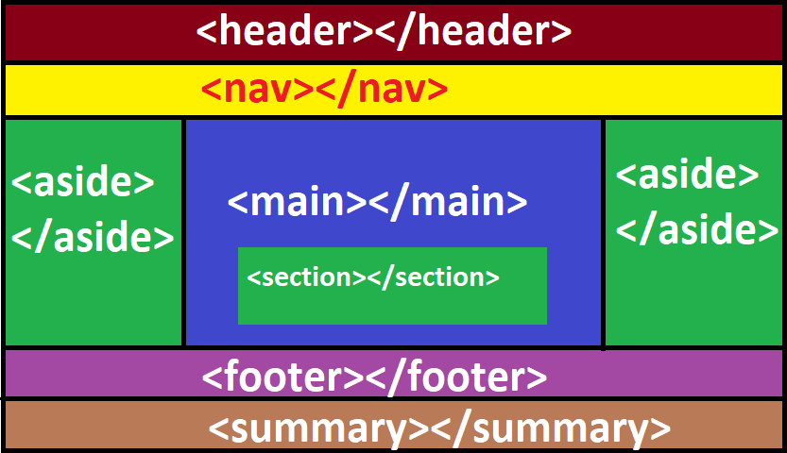Ex.

<header></header> <nav></nav>

<main></main> <section></section> <footer></footer>

<summary></summary>

<audio></audio>

<video></video> **Structure** **of** **Webpage** DOCTYPE

ROOT SECTION

HEAD SECTION

METADATA BODY SECTION

MAIN CONTENT

DOCTYPE Representing version of HTML

Browsers only understands the DOCTYPE

Below DOCTYPE Representing HTML5.X

<!DOCTYPE html>

<html></html> tag used to create the ROOT SECTION

ROOT SECTION Divided into two sections

HEAD SECTION

BODY SECTION

<head></head> tag used to create the HEAD SECTION

<body></body> tag used to create the BODY SECTION

Data about webpage called as METADATA Ex.

Author Description Title

we will define METADATA under HEAD SECTION

we will define Main Content under BODY SECTION Ex.

Tables

Forms Headings Paragraphs Images

<!DOCTYPE html>

<html>

<head>

//METADATA

</head>

<body>

//MAIN CONTENT

</body>

</html>

**Software** **Installation**

download and install Visual Studio Code

Visual Studio Code is the IDE.

Visual Studio Code provided by "Microsoft" and "open source".

Visual Studio Code is "recommended" to develop "web applications"

website: https://code.visualstudio.com/docs/?dv=win file: VSCodeUserSetup-x64-1.77.3.exe

install Live Server plugin

Live Server plugin watches application changes

Live Server plugin gives "changes notification" to browser

browser will "reload/refresh" automatically

open the "VSCode" ==> Click "Extensions" ==> Search "Live Server" ==>Select "Live Server" ==> Click "install"

install "Dummy Text Generator" Plugin

"Dummy Text Generator" Plugin generates content randomly

open the "VSCode" ==> click "Extensions" ==> Search "Dummy Text Generator" ==> select "Dummy Text Generator" ==> click "install"

Enable "AutoSave" Settings

Application will save Automatically without "ctrl+s"

open the "VSCode" ==> click the "Manage" ==> click "settings"

**==>** **choose** **"AutoSave"** **==>** **select** **"afterDelay"**

install browser

Google Chrome

Firefox

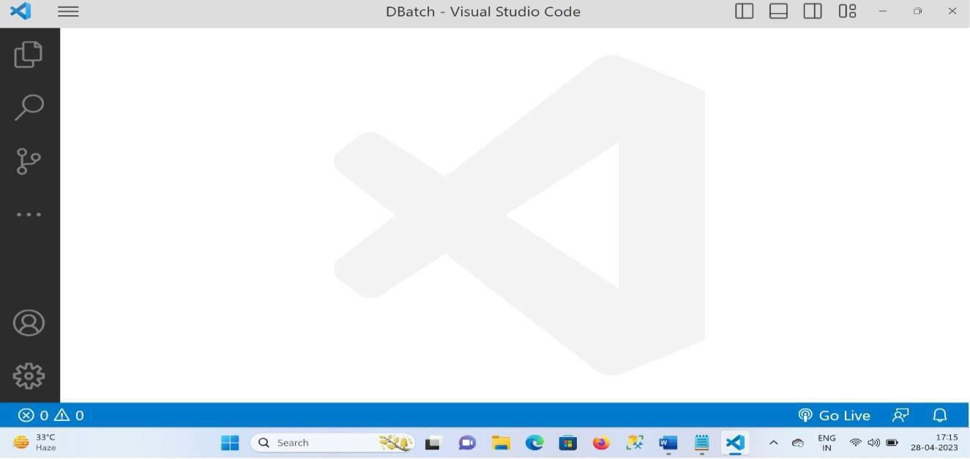

Headings in HTML

External CSS

Padding in CSS

Block Level Elements

**Headings** **in** **HTML**

**HEADINGS**

HTML Supports 6 types of Headings

<h1></h1> main heading

<h2></h2> sub heading

<h3></h3> ""

<h4></h4> ""

<h5></h5> ""

<h6></h6> ""

**External** **CSS**

<link> tag, used to include the external CSS file

<link> tag is non paired tag

<link> tag supports two attributes

href

rel

**Padding**

space around the content called as padding

Ex.

padding:20px;

**Block** **Level** **Element**

Block Level Elements Starts with new line

Headings are Example for Block Level Elements

headings.html

<!DOCTYPE html>

<html>

<head>

<title>Headings</title>

<link rel="stylesheet" href="headings.css">

</head>

<body>

<h1>ExcelR</h1>

<h2>ExcelR</h2>

<h3>ExcelR</h3>

<h4>ExcelR</h4>

<h5>ExcelR</h5>

<h6>ExcelR</h6>

</body>

</html>

**headings.css**

h1,h2,h3,h4,h5,h6{ color: red;

background-color: yellow; text-align: center; padding: 20px;

border: 1px solid red; width: 50%;

border-radius: 0px 60px;

box-shadow: 0px 0px 20px red;

}

Text Formatting Tags

<b></b> bold text

<strong></strong> strong text

<i></i> italic text

<em></em> emphasized text

<u></u> underlined text

<del></del> deleted text

<strike></strike> strike text

<mark></mark> marked text

<sup></sup> superscript

<sub></sub> subscript

<big></big> big text

<small></small> small text

<code></code> represent the computer code

<var></var> mathematical formulas

<br> line break

<hr> horizontal line

<address></address> display address

<abbr></abbr> abirritations

title attribute used to define abbreviation

<bdo dir=""></bdo> bi directional override

<blockquote></blockquote> represent the quotations

**Example**

<!DOCTYPE html>

<html>

<head>

<title>Text Formatting Tags</title>

</head>

<body>

This is <b>Bold</b> Text <br>

This is <strong>strong</strong> text <br> This is <i>Italic</i> Text <br>

This is <em>Emphasized</em> Text <br> This is <u>underlined</u> Text <br>

This is <del>Deleted</del> Text <br> This is <strike>Striked</strike> Text <br>

This is <mark>Marked</mark> Text <br> a<sup>2</sup>+b<sup>2</sup> <br> H<sub>2</sub>O <br>

This is <big>Big</big> Text <br>

This is <small>small</small> Text <br>

<code>for (int i=0; i<10; i++) {} </code> <br>

<var>a2+b2</var> <br>

<hr>

<address>

ExcelR <br>Ameerpet

<br> Hyderabad

</address>

<br>

<abbr title="Hyper Text Markup Language"> HTML

</abbr>

<br>

<bdo dir="rtl">Welcome to UI Technologies</bdo>

<br>

<blockquote>

Stay Home Stay Safe

</blockquote>

</body>

</html>

**Output**

Paragraphs in HTML

Inline Elements

**PARAGRAPHS**

Converting Block Level Elements to Inline Elements

Converting Inline Elements to Block Level Elements

Margin in CSS

Box Model in CSS

Paragraphs

<p></p> tag, used to display paragraphs

<p></p> tag also block level element

Inline Elements

each element never starts with the new line (Inline elements displays horizontally)

Converting Block Level Elements to Inline Elements in CSS

Below snippet used to convert block level elements to inline elements

Ex.

display: inline-block;

**Converting** **Inline** **Elements** **to** **Block** **Level** **Elements** **in** **CSS**

Below snippet used to convert inline elements to block level elements

Ex.

display: block;

**Margin** **in** **CSS**

space around the element called as margin

Ex.

box-model in CSS

margin: 20px

combination of padding, border and margin called as box-model in CSS

Example:

paragrahs.html

<!DOCTYPE html>

<html>

<head>

<title>Paragraphs</title>

<link rel="stylesheet" href="paragraphs.css">

</head>

<body>

<p>

Lorem ipsum dolor sit amet consectetur adipisicing elit. Magnam cum numquam, ab blanditiis laudantium nemo odit perspiciatis officia itaque tenetur ut. Natus praesentium dolore magnam.

</p>

<p>

Lorem ipsum dolor sit amet consectetur adipisicing elit. Magnam cum numquam, ab blanditiis laudantium nemo odit perspiciatis officia itaque tenetur ut. Natus praesentium dolore magnam.

</p>

<p>

Lorem ipsum dolor sit amet consectetur adipisicing elit. Magnam cum numquam, ab blanditiis laudantium nemo odit perspiciatis officia itaque tenetur ut. Natus praesentium dolore magnam.

</p>

</body>

</html> paragraphs.css p{

border: 1px solid red; width: 20%;

display: inline-block; padding: 20px; margin: 20px; border-radius: 20px; text-align: justify;

font-family: Comic Sans MS; color: white;

background: linear-gradient(45deg,red,black);

}

Output

divisions in html

internal CSS

DIVISIONS

differences between internal CSS and external CSS

selectors

class selector

id selector

element selector

universal selector

differences between class selector and id selector

divisions in html

Divisions are used to divide webpage into multiple sections

<div></div> tag used to create divisions in webpages

<div></div> tag also block level element

internal CSS

<style></style> tag used to write internal CSS

differences between internal CSS and external CSS

|  |  |
| --- | --- |
| **Internal** **CSS** | **External** **CSS** |
| <style></style> tag used to write the internal CSS | <link> tag, used to include the external CSS |
| <style></style> tag is paired tag | <link> tag is non paired tag |
| we can achieve CSS reusability through external CSS | we can't reuse CSS through internal CSS |

**selectors**

Selector "Selects" Particular "HTML Elements" to apply CSS

Types of Selectors

class selector

id selector

element selector / tag selector

universal selector

class selector

class selector should start with "." (dot)

Syntax

HTML CSS

***** ***

<div class="c1"> .c1{

</div> }

id selector

id selector should start with "#"

Syntax

HTML CSS

***** ***

<div id="id1"> #id1{

</div> }

element selector

element selector starts with "tag" name

Syntax

HTML CSS

***** ***

<div> div {

</div> }

universal selector

we will represent "universal selector" with "*"

CSS applied to "all elements" through "universal selector"

differences between class selector and id selector

|  |  |
| --- | --- |
| **Class** **selector** | **Id** **selector** |
| class selector starts with . (dot) | id selector starts with "#" |
| we may duplicate class | Id should be unique |
| we can apply more than one class Ex.  <div class="c1 c2 c3">  </div> | we can apply only one id Ex.  <div id="id1">  </div> |
| class selector has less priority compared to id selector  (specificity) | id selector has more priority compared to class selector  (specificity) |
| if a greater number of teams working on same project, then class selector  is suggested | to override 3rd party CSS then we will use id selector |

**Example** **divisions.html**

<!DOCTYPE html>

<html>

<head>

<title>Divisions</title>

<style> div{

border: 1px solid gray; width: 25%;

display: inline-block; padding: 10px; margin: 10px; border-radius: 20px;

}

h1{

color: red;

text-align: center;

}

p{

text-align: justify;

font-family: Comic Sans MS; color: white;

}

.c1{

background: linear-gradient(90deg,green,yellow);

}

#id1{

background: linear-gradient(90deg,pink,yellow);

}

#id2{

background: linear-gradient(90deg,black,blue);

}

</style>

</head>

<body>

<div class="c1">

<h1>HTML</h1>

<p>

Lorem ipsum dolor, sit amet consectetur adipisicing elit. Aperiam alias esse ducimus, atque quidem exercitationem saepe. Maiores fugit praesentium mollitia iste magnam sunt earum facilis?

</p>

</div>

<div id="id1">

<h1>CSS</h1>

<p>

Lorem ipsum dolor, sit amet consectetur adipisicing elit. Aperiam alias esse ducimus, atque quidem exercitationem saepe. Maiores fugit praesentium mollitia iste magnam sunt earum facilis?

</p>

</div>

<div id="id2">

<h1>JAVASCRIPT</h1>

<p>

Lorem ipsum dolor, sit amet consectetur adipisicing elit. Aperiam alias esse ducimus, atque quidem exercitationem saepe. Maiores fugit praesentium mollitia iste magnam sunt earum facilis?

</p></div></body>

</html>

**Output**

Buttons, span, images and Inline CSS

**Button**

**applying** **css** **to** **webpages**

**CSS** **Specificity** **(Priority)**

**Span**

**Images**

**Hover** **in** **CSS** **Button**

<button></button> tag used to display Buttons in webpages

<button></button> tag is inline element Ex.

<button>

Login

</button>

Example buttons.html

<!DOCTYPE html>

<html>

<head>

<title>Buttons</title>

</head>

<body>

<button style="width: 100px; height: 100px; background-color: yellow; color: red;

border: 1px solid red; border-radius: 20px;">

Button1

</button>

<button style="width: 100px; height: 100px;

background-color: orangered; color: white;

border: 1px solid yellowgreen; border-radius: 20px;">

Button2

</button>

</body>

</html>

**Output:**

**applying** **css** **to** **webpages**

we can apply css to webpages in three ways

external css

internal css

inline css

external css

<link> tag used to include the external css

through external css we can achieve css reusability

internal css

<style></style> tag used to write the internal css through internal css we can't reuse the css

inline css

style attribute used to apply the inline css through "inline css" also we can't reuse the css

**CSS** **Specificity** **(Priority)**

CSS priorities are defined below like this

Ex. span

**inline** **>** **id** **>** **class** **>** **element**

wrap particular "content" from "text", we will use span

<span></span> tag is inline element

<span></span> tag used to display validation messages

Example span.html

<!DOCTYPE html>

<html>

<head>

<title>SPAN</title>

</head>

<body>

<p>

welcome to <span style="color: red;">ui</span> technologies

</p>

</body>

</html>

Output

**Images**

<img> tag used to display the images

<img> tag is non paired tag

<img> tag is inline element Attributes

width

used to define image width

height

used to define image height

src

alt

Example Images.html

refers image page

whenever image displays fail automatically alternative text will display

<!DOCTYPE html>

<html>

<head>

<title>Images</title>

<style>

img{

margin: 20px;

border: 2px solid blue;

}

.c1:hover{ width: 200px; height: 150px;

border: 2px solid red;

}

.c2:hover{ height: 150px;

border-radius: 100%; border-color: green;

}

.c3:hover{ display: none;

}

</style>

</head>

<body>

<img width="150px" height="100px" src="flipkart.png" alt="Error" class="c1">

<img width="150px" height="100px" src="amazon.png" alt="Error" class="c2">

<img width="150px" height="100px" src="myntra.png" alt="Error" class="c3">

</body>

</html> Output:

**Hover**

Hover is a pseudo class in css

Whenever mouse over a particular element automatically hover effect will execute

Syntax

.c1: hover {

//css code

}

#id1: hover {

//css code

}

Img: hover {

//css code

}

**Hyperlinks,** **FieldSet,** **Marquee,** **TextFormating** **Tags**

**Hyperlinks**

**Fieldset**

**Marquee** **Hyperlinks**

<a></a> tag used to create the hyper links

<a></a> tag used to navigate from one web page to another Webpage

<a></a> tag also used to send emails

<a></a> tag also used to open the external websites

<a></a> tag is inline element Attributes

href

used to link the path of "target resource"

target="_blank"

used to open the "new tab" in browser

Example1:

Code 1.html

<!DOCTYPE html>

<html>

<head>

<title>Anchor</title>

</head>

<body>

<a href="page2.html" target="_blank"> Next

</a>

</body>

</html>

page2.html

<!DOCTYPE html>

<html>

<head>

<title>Page2</title>

</head>

<body>

<h1>Welcome to Page2... !</h1>

</body>

</html>

Example2:

**Example**

<!DOCTYPE html>

<html>

<head>

<title>Websites Example</title>

</head>

<body>

<a href="https://[www.myntra.com/](http://www.myntra.com/)" target="_blank" style="margin: 40px;">

Myntra

</a>

<a href="https://[www.amazon.in/](http://www.amazon.in/)" target="_blank" style="margin: 20px;">

<button>Amazon</button>

</a>

<a href="https://[www.flipkart.com/](http://www.flipkart.com/)" target="_blank">

<img width="50px" height="50px" src="flipkart.png" alt="Error">

</a>

</body>

</html>

**Fieldset**

this tag used to create rectangular structures Ex.

<fieldset>

<legend>LOGIN FORM</legend>

</fieldset> Example: fieldset.html

<!DOCTYPE html>

<html>

<head>

<title>Fieldset</title>

<style>

fieldset{ width: 25%;

border-color: red; border-radius: 20px;

}

legend{

background-color: yellow; color: red;

padding: 5px; border: 2px solid red; border-radius: 20px;

}

p{

text-align: justify;

font-family: Comic Sans MS; color: red;

}

</style>

</head>

<body>

<fieldset>

<legend>LOGIN FORM</legend>

<p>

Lorem, ipsum dolor sit amet consectetur adipisicing elit. Possimus, quaerat tenetur debitis libero et sequi doloremque ratione aperiam fugiat cum. Praesentium, fugiat. Voluptates, deleniti. Omnis!

</p>

</fieldset>

</body>

</html>

Output:

# TABLES

* collection of rows and columns called as table

### TAGS

* <table></table> tag used to create the tables
* <tr></tr> tag used to create table row
* <th></th> tag used to display table heading
* <td></td> tag used to display cell data

### Attributes

1. border

it is used to draw the border to the table Ex.

border="1"

1. align="left"/"center"/"right"

it is used to align the table default value is "left"

1. cellspacing

it is used to maintain space between cells Ex.

cellspacing="10px"

1. cellpadding

space around cell content called as cellpadding Ex.

cellpadding="10"

1. colspan

it is used to merge the cells horizontally Ex.

colspan="2"

1. rowspan

it is used to merge the cells vertically Ex.

rowspan="2"

Examples

******** table1.html

<!DOCTYPE html>

<html>

<head>

<title>Tables</title>

</head>

<body>

<table border="1"

align="center" cellspacing="20px" cellpadding="20px">

<tr>

<th>E_ID</th>

<th>E_NAME</th>

<th>E_SAL</th>

</tr>

<tr>

<td>111</td>

<td>E_ONE</td>

<td>10000</td>

</tr>

<tr>

<td>222</td>

<td>E_TWO</td>

<td>20000</td>

</tr>

<tr>

<td>333</td>

<td>E_THREE</td>

<td>30000</td>

</tr>

<tr>

<td>444</td>

<td>E_FOUR</td>

<td>40000</td>

</tr>

<tr>

<td>555</td>

<td>E_FIVE</td>

<td>50000</td>

</tr>

</table>

</body>

</html>

Output:

table2.html

<!DOCTYPE html>

<html>

<head>

<title>TABLES</title>

</head>

<body>

<table border="1"

align="center" cellspacing="10px" cellpadding="10px">

<tr>

<th>P_ID</th>

<th>P_NAME</th>

<th>P_COST</th>

<th>P_IMAGE</th>

<th>UPDATE</th>

<th>DELETE</th>

</tr>

<tr>

<td>111</td>

<td>P_ONE</td>

<td>10000</td>

<td>

<img src="flipkart.png" width="100px" height="100px" alt="Error">

</td>

<td>

<button>UPDATE</button>

</td>

<td>

<button>DELETE</button>

</td>

</tr>

<tr>

<td>222</td>

<td>P_TWO</td>

<td>20000</td>

<td>

<img width="100px" height="100px" src="amazon.png" alt="Error">

</td>

<td>

<button>UPDATE</button>

</td>

<td>

<button>DELETE</button>

</td>

</tr>

<tr>

<td>333</td>

<td>P_THREE</td>

<td>30000</td>

<td>

<img width="100px" height="100px" src="myntra.png" alt="Error">

</td>

<td>

<button>UPDATE</button>

</td>

<td>

<button>DELETE</button>

</td>

</tr>

</table>

</body>

</html>

Output:

tables3.html

<!DOCTYPE html>

<html>

<head>

<title>TABLES</title>

<link rel="stylesheet" href="https://cdnjs.cloudflare.com/ajax/libs/font- awesome/4.7.0/css/font-awesome.min.css">

</head>

<body>

<table border="1"

align="center" cellspacing="10px" cellpadding="10px">

<tr>

<th>NAME</th>

<th>DELETE</th>

<th>UPDATE</th>

</tr>

<tr>

<td>LAPTOP</td>

<td>

<i class="fa fa-trash"></i>

</td>

<td>

<i class="fa fa-edit"></i>

</td>

</tr>

<tr>

<td>WATCH</td>

<td>

<i class="fa fa-trash"></i>

</td>

<td>

<i class="fa fa-edit"></i>

</td>

</tr>

<tr>

<td>

MOBILE

</td>

<td>

<i class="fa fa-trash"></i>

</td>

<td>

<i class="fa fa-edit"></i>

</td>

</tr>

</table>

</body>

</html> Output

table4.html

<!DOCTYPE html>

<html>

<head>

<title>TABLES</title>

</head>

<body>

<table border="1"

align="center" cellspacing="10px" cellpadding="10px">

<tr>

E_DEPT</th>

<th>E_ID</th>

<th>E_NAME</th>

<th>E_SAL</th>

<th colspan="2">E_DESIGNATION &

</tr>

<tr>

<td>E101</td>

<td>E_ONE</td>

<td>10000</td>

<td>Jr Engg</td>

<td rowspan="2">CSE <br> IT</td>

</tr>

<tr>

<td>E102</td>

<td>E_TWO</td>

<td>20000</td>

<td>Sr Engg</td>

</tr>

<tr>

<td colspan="3">E103 & E_THREE &30000</td>

<td rowspan="3">Team Lead <br><br> Manager

<br><br> Sr Manager</td>

<td>ECE</td>

</tr>

<tr>

<td>E104</td>

<td>E_FOUR</td>

<td>50000</td>

<td>MECH</td>

</tr>

<tr>

<td>E105</td>

<td>E_FIVE</td>

<td>50000</td>

<td>EEE</td>

</tr>

</table>

</body>

</html> Output

tables5.html

<!DOCTYPE html>

<html>

<head>

<title>TABLES WITH CSS</title>

<style>

table{

width: 100%;

text-align: center; border: 1px solid gray; border-collapse: collapse;

}

th,td{

border: 1px solid gray;

}

th{

}

td{

}

height: 50px; height: 30px;

tr:nth-child(even){ background-color: yellow; color: red;

}

tr:nth-child(odd){ background-color: orange; color: white;

}

tr:hover{

background-color: burlywood;

}

</style>

</head>

<body>

<table>

<tr>

<th>SNO</th>

<th>SNAME</th>

<th>CLASS</th>

</tr>

<tr>

<td>1</td>

<td>SONE</td>

<td>DBatch</td>

</tr>

<tr>

<td>2</td>

<td>STWO</td>

<td>CBatch</td>

</tr>

<tr>

<td>3</td>

<td>STHREE</td>

<td>BBatch</td>

</tr>

<tr>

<td>4</td>

<td>SFOUR</td>

<td>ABatch</td>

</tr>

</table>

</body></html>

